# 2、Nginx+Tomcat中https转http请求问题

问题：https 请求tomcat资源时，资源加载显示异常

was loaded over HTTPS, but requested an insecure

解决方案：

2.1 Nginx对应server的location添加配置

|  |
| --- |
| proxy_set_header Host $host;  proxy_set_header X-Real-IP $remote_addr;  proxy_set_header X-Forwarded-For $proxy_add_x_forwarded_for;  proxy_set_header X-Forwarded-Proto $scheme; |

2 .2Tomcat的配置srever.xml

2.2.1 connector里添加

|  |
| --- |
| redirectPort="443" proxyPrort="443" |

2.2.2 Host里添加

|  |
| --- |
| <Valve className="org.apache.catalina.valves.RemoteIpValve" protocolHeaderHttpsValue="https" remoteIpHeader="X-Forwarded-For" protocolHeader="X-Forwarded-Proto" /> |

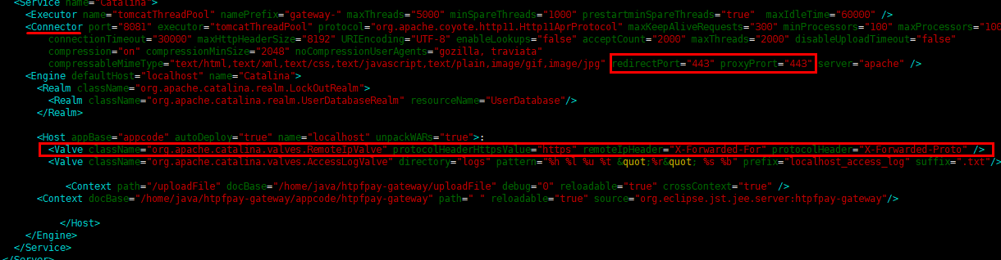

2.3 在防火墙里添加443端口的入站规则

参考URL：<https://blog.csdn.net/mg4848/article/details/78481411/>